
INTERNATIONAL SOCIOLOGICAL ASSOCIATION

L’Association Internationale de Sociologie/
Asociación Internacional de Sociología
and
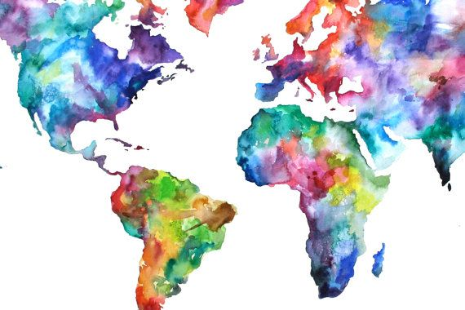
Reading list

&

"THE ELIMINATION AND PREVENTION OF ALL FORMS OF VIOLENCE AGAINST WOMEN AND GIRLS"

“WOMEN’S EMPOWERMENT AND ITS LINK TO SUSTAINABLE DEVELOPMENT”

Africa

Berry, M. E. (2015). When “bright futures” fade: Paradoxes of women’s empowerment in Rwanda. Signs: Journal of Women in Culture and Society, 41(1) 1-27.

Chinwuba, N.N. (2015). Ending inequality in Nigeria: A refreshing approach from the nation’s judiciary. International Journal of Law, Policy & the Family, 29(3) 341-350.

Dibie, J. & Dibie, R. (2012). Non-governmental organizations (NGOs) and the empowerment of women in Africa. African & Asian Studies, 11(1/2), 95-122.

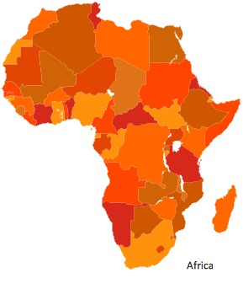
Ojokoh, B. A., Adeola, O. S., Isinkaye, F. O., & Abraham, C. O. (2014). Career choices in information and communication technology among south western Nigerian women. Journal of Global Information Management, 22(2), 48-77.

Olomukoro, C. & Adoleore, O. (2015). Political empowerment of women through literacy education programmes in EDO and Delta States, Nigeria. Journal of Adult and Continuing Education, 21(2), 2-23.

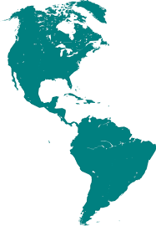
Simmonds, S. (2014). Curriculum-making in South Africa: Promoting gender equality and empowering women? Gender and Education, 26(6), 636-652.

The Americas

Biotta, M., Fullone, B., Fuentes, A., Galizia, B., Gancedo, N. (2011). La violencia de género y el acceso a la justicia de las mujeres en la provincia de Santa Fe - Argentina. Revista de Estudios Juridicos UNESP, 15(22), 309-324
Elemi, J., Sanchez, H., Falconi, R. (2015). Empoderamiento en mujeres Mexicanas: Experiencias de mujeres líderes de México. Cuestiones de Género: de la Igualdad y la Diferencia, 10, 419-434.
Hynes, M., Sterk, C. E., Hennink, M., Patel, S., DePadilla, L. & Yount, K. (2016). Exploring gender norms, agency and intimate partner violence among displaced Colombian women: A qualitative assessment. Global Public Health: An International Journal for Research, Policy and Practice, 11(1-2), 17-33.
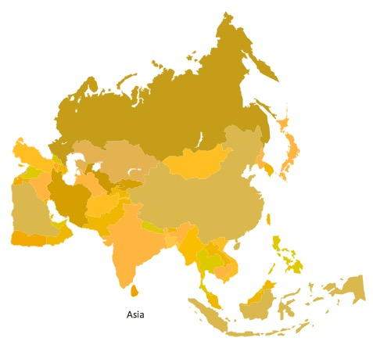
Roure, J.D. (2011). Gender justice in Puerto Rico: Domestic violence, legal reform, and the use of international human rights principles. Human Rights Quarterly, 33 (3), 790-825.

Asia

Afridi, F. (2010). Women's empowerment and the goal of parity between the sexes in schooling in India. Population Studies, 64(2), 131–145.

Aladuwaka, S., & Momsen, J. (2010). Sustainable development, water resources management and women's empowerment: the Wanaraniya Water Project in Sri Lanka. Gender and Development, 18(1) 43–58.

Kieran, C., Sproule, K., Doss, C. Quisumbing, A. & Kim, M. (2015). Examining gender inequalities and land rights indicators in Asia. Agricultural Economics, 46(1), 119-138.

Kim, J. (2013). Gender difference in employment and income in China’s labor market. The Journal of East Asian Affairs, 27(2), 31–53.

Narciso, V. (2010). Women and land in Timor-Leste: Issues in gender and development. Indian Journal of Gender Studies, 17(1), 49-72.

Padney, S., Lama, G. & Lee, H. (2012). Effects of women’s empowerment on their utilization of health services: A case of Nepal. International Social Work, 55(4), 554-573.

Pandey, S. (2010). Rising property ownership among women in Kathmandu, Nepal: An exploration of causes and consequences. International Journal of Social Welfare, 19(3), 281-292.

Subramaniam, M. (2012). Grassroots groups and poor women’s empowerment in rural India. International Sociology, 27(1), 72-95.

Xiaoxian, G. (2010). From the Heyang Model to the Shaanxi Model: Action research on women's participation in village governance. The China Quarterly, 204, 870–898.

Yang, Y.-M., Wang, H.-H., Lee, F.-H., Lin, M.-L., & Lin, P.-C. (2015). Health empowerment among immigrant women in transnational marriages in Taiwan. Journal of Nursing Scholarship, 47(2), 135-142.

Young-Mi, K. & Sawako, S. (2014). Understanding intra-regional variation in gender inequality in East Asia: Decomposition of cross-national differences in the gender earnings gap. International Sociology, 29(3), 229-248.

Yousaf, F. and Purkayastha, B. (2016). Beyond saving faces: Survivors of acid attacks in Pakistan. Woman’s Studies International Forum, 54, 11-19.

Yousaf, F. & Purkayastha, B. (2015). ‘I am only half alive’: Organ trafficking in Pakistan amid interlocking oppressions. International Sociology, 30(6), 637-653.

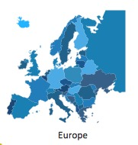

Europe

Cichowski, R. A. (2013). Legal mobilization, transnational activism, and gender equality in the EU. Canadian Journal of Law & Society/Revue Canadienne Droit Et Societe, 28(2), 209-227.

Gąciarz, B. (2011). Women in the workplace in Poland. International Journal of Sociology, 41(3), 68-94.

Payne, S. (2014). Constructing the gendered body? A critical discourse analysis of gender equality schemes in the health sector in England. Current Sociology, 62(7), 956-974.


Global

Abraham, M. (2010). Contours of citizenship: Women, diversity and practices of citizenship. Farnham, England: Ashgate.

Akchurin, M., & Lee, C. S. (2013). Pathways to empowerment: Repertoires of women’s activism and gender earnings equality. American Sociological Review, 78(4), 679–701.

Barberet, R. (2014). Women, crime and criminal justice: A global enquiry. London: Routledge.

Boyle, E. H., & Corl, A. C. (2010). Law and culture in a global context: Interventions to eradicate female genital cutting. Annual Review of Law and Social Science 6, 195–215.

Bose, C.E (2015). Patterns of global gender inequalities and regional gender regimes. Gender and Society, 29, 767-791.

Erturk, Y. & Purkayastha, B. 2012. Linking research, policy and ction: A look at the work of the special rapporteur on violence against women. Current Sociology, edited by Margaret Abraham and Bandana Purkayastha. 60, 20-39.

Fritz, J. M. (2016). Social justice for women and girls: Global pacts, unmet goals, environmental issues, In Globalization, environment and social justice: Perspectives, issues and concerns edited by Manish Kumar Verma.

Fritz, J. M. (2014). UN security council resolution 1325, inclusive peacebuilding and countries in transition. In Moving toward a just peace: The mediation continuum edited by Jan Marie Fritz. Dordrecht/Heidelberg/New York/London: Springer.

Hague, G. (2013). Learning from each other: The special cell and domestic violence activist responses in different contexts across the world. Violence Against Women 19(10), 1224-1245.

Hughes, C., M. Bolis, R. Fries, and S. Finigan. (2015). Women's economic inequality and domestic violence: Exploring the links and empowering women. Gender and Development 23(2), 279-297.
Mayoax, L. (2010). Reaching and empowering women: Towards a gender justice protocol for a diversified, inclusive, and sustainable financial sector. Perspectives on Global Development & Technology, 9(3/4), 581-600.
Patil, V. & Purkayastha, B. (2015). Sexual violence, race, media (in) visibility: Intersectional complexities in a transnational frame. Societies, 598–617.

Purkayastha, B. & Ratcliff, K. (2014). Routine violence: Intersectionality at the interstices. Advances in Gender Research, Volume 18B Edited By Marcia Segal and Vasiliki Demos. London: Emerald Publications.

Sandole, D. & Staroste, I. (2015). Making the case for systemic, gender-based analysis in sustainable peace building. Conflict Resolution Quarterly, 33(2), 119-147.
Terry, G. (2009). No climate justice without gender justice: an overview of the issues. Gender and Development, 17(1), 5–18.
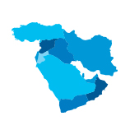

Middle East

Fritz, J. M. (2014). Women, girls and transitions from autocracy. In The Arab uprisings: Sociological perspectives and geographical comparisons edited by Sari Hanafi, Marlene Nasr and Diab Chebib. Beirut, Lebanon: Farabi.

Mohamdieh, K (2012). No revolutions without equality and justice: The struggle for women’s rights in rethinking development in the Arab region. Development, 55(3), 369-381.

Nasser, R., Barghouti, F., & Mousa, J. (2010). Feminist attitudes and praxis among Palestinian women activists. Feminist Formations, 22(3), 146–175.


Rezai-Rashti, G. M., & Moghadam, V. M. (2011). Women and higher education in Iran: What are the implications for employment and the "marriage market"? International Review of Education, 57(3/4), 419–441.

Compiled by Sarah Fox and Kelvin Rodriguez, John Jay College of Criminal Justice,

ISA Youth Representatives to the UN

